Walk through the changes in the data block as rows are inserted, updated, and deleted. Explain how PCTFREE and PCTUSED affect the scenario you described.

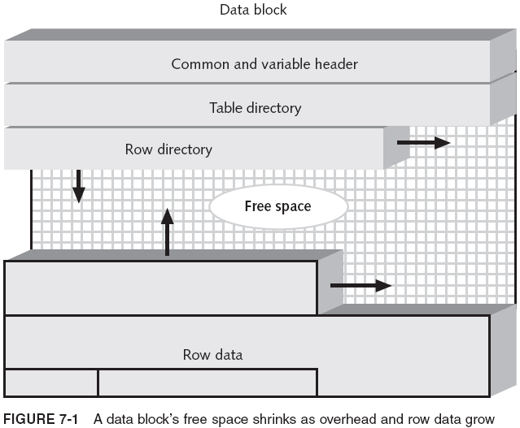

The Common & Variable Header lists what type of segment (table, view, index) the data block is and the address of the data block. It does not change. Similarly, the table directory discusses the specific name of the segment (table, view, index) the data block contains data for. This also does not change.

Row Data is modified obviously by adding data upon an insert statement, removing data in a delete statement, and modifying existing data in an update statement.

Row directory space is not reclaimed in any scenario as the space allocated to the row directory does not change. If a new row is added to a data block, it can be inserted over the top a row directory which no longer has data within the row data section of the data block.

When inserting a new row, the PCTUSED parameter determines whether the row will be inserted into a new data block or be placed within the free space of an existing data block. By default, Oracle allocates 90% of the block size for new rows, while 10% of the block exists for updates (these are the parameters of PCTFREE). When inserting a new row, Oracle will check to see if a block has more space available than the PCTUSED parameter (which defaults to 40). If Oracle cannot find a block with more space than PCTUSED, the new row will be placed in a new data block (or chained to another data block if two blocks combined have enough space available for the row).

PCTFREE is decreased when a row is inserted, while DELETE and UPDATE statements can increase the size of free space. The new space created can hold new data in the data block entered by INSERT statements after the DELETE/UPDATE has been committed (or if the insert is in the same transaction as the DELETE/UPDATE).

http://download-uk.oracle.com/docs/cd/B19306_01/server.102/b14220/logical.htm

